Pollution Incident Response Management Plan

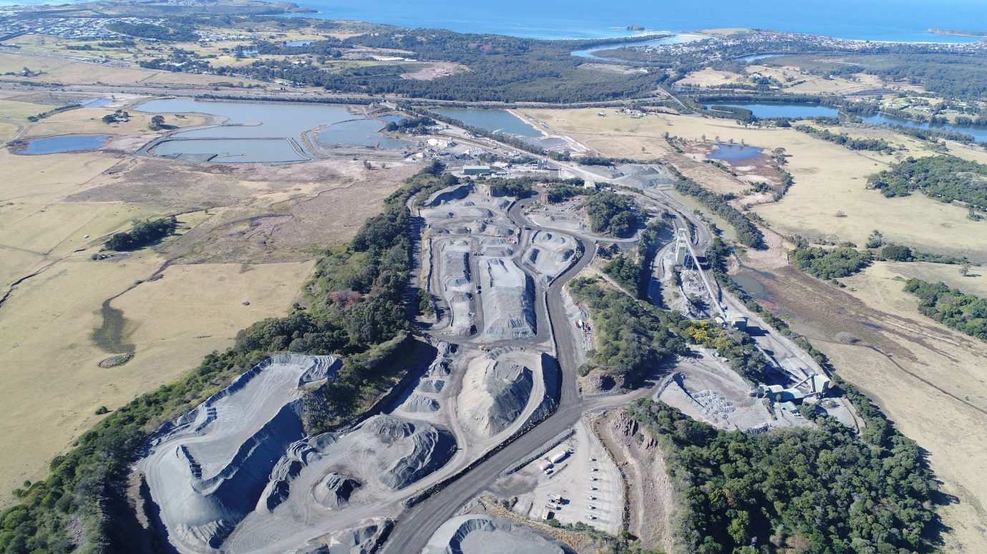

Dunmore Quarry

Version 13: 26 August 2019

DOCUMENT CONTROL SHEET

Version | Date | Prepared By | Approved By | Revision Details
01 | 20 Aug 2012 | Rod Johnson | Rod Johnson | Document Created
02 | 21 Nov 2012 | Philip Paterson | Rod Johnson | Document control sheet added  Incidents updated
03 | 12 Apr 2013 | Ronnie Lawton | Rod Johnson | Format Changes  Added additional maps  Chemical volumes stored onsite added
04 | 28 Aug 2013 | Mel Goodall | Rod Johnson | Incidents updated  Pit area added to map  Contacts updated to reflect staff changes
05 | 01 Sep 2014 | Phil Paterson | Rod Johnson | Contacts updated to reflect staff changes  Format Changes  Added Additional maps
06 | 25 Sept 2015 | Phil Paterson | Rod Johnson | Contacts updated  Format changes
07 | 7 Oct 2016 | Ronnie Lawton | Brodie Bolton | Contacts updated  Format changes  Updated incident #5 and #10 response actions
08 | 24 Jan 2017 | Ronnie Lawton | Glenn Troy | Contacts updated
09 | 14 June 2017 | Ellie Randall | Glenn Troy | Contacts updated
10 | 3 August 2017 | Ellie Randall | Glenn Troy | Incident Updates
11 | 21 May2018 | Ben Williams | Dylan Treadwell | Contacts Updated
12 | 30 October 2018 | Ben Williams | Brodie Bolton | Updated based on feedback from EPA
13 | 26 Aug 2019 | Ben Williams | Rod Johnson | Updated based on new PIRMP template

Current Revision | Date Implemented | PIRMP Test Schedule | Date for Next Review
13 | 26 August 2019 | 12 months | 26 August 2020

Contents
1. DOCUMENT CONTROL SHEET 2
2. PURPOSE 4
3. LEGISLATIVE REQUIREMENTS 4
4. DEFINITION OF A ‘POLLUTION INCIDENT’ 4
5. SCOPE 5
6. POTENTIAL POLLUTING SUBSTANCES 6
7. ROLES AND RESPONSIBILITIES 11
8. INTERNAL POLLUTION INCIDENT REPORTING 11
9. EXTERNAL POLLUTION REPORTING 13
10. POLLUTION INCIDENT AUTHORITY CONTACT LIST 14
11. INCIDENT REPONSE TRAINING 16
12. PIRMP AUDIT 17
13. PIRMP REVIEW 17
13.1. EVENT BASED 17
13.2. TIME BASED 17
14. APPENDIX A: RISK ASSESSMENT ON POTENTIAL IMPACTS 18

PART A

PURPOSE
The purpose of the Dunmore Quarry Pollution Incident Response Plan is to:
- Provide direction to the staff at Dunmore Quarry in responding to pollution incidents at the Dunmore operations;
- Ensure timely communication about a pollution incident is provided to staff at the premises, the Environment Protection Authority (EPA), other relevant authorities specified in the Protection of the Environment Legislation Amendment Act (POELA Act) (including Shellharbour City Council, NSW Ministry of Health, Safework NSW, and Fire and Rescue NSW) and persons outside the operations who may be affected by the impacts of a pollution incident that is not trivial;
- Minimise and control the risk of a pollution incident at Dunmore Quarry by identifying key risks and planned actions to minimise and manage those risks;
- Detail the training requirements for this plan, identifying persons responsible for implementing it, and ensuring that the plan is regularly tested for accuracy, currency and suitability.

LEGISLATIVE REQUIREMENTS
The specific requirements for a Pollution Incident Response Management Plan (PIRMP) are set out in Part 5.7A of the POEO Act and the Protection of the Environment Operations (General) Regulation 2009 (POEO(G) Regulation). In summary, this provision requires the following:
- All holders of environment protection licences must prepare a pollution incident response management plan (section 153A, POEO Act).
- The plan must include the information detailed in the POEO Act (section 153C) and be in the form required by the POEO(G) Regulation (clause 98B).
- Licensees must keep the plan at the premises to which the environment protection licence relates (section 153D, POEO Act).
- Licensees must test the plan in accordance with the POEO(G) Regulation (clause 98E).
- if a pollution incident occurs in the course of an activity so that material harm to the environment is caused or threatened, licensees must immediately implement the plan (section 153F, POEO Act).

DEFINITION OF A ‘POLLUTION INCIDENT’
The definition of a pollution incident is:
“pollution incident means an incident or set of circumstances during or as a consequence of which there is or is likely to be a leak, spill or other escape or deposit of a substance, as a result of which pollution has occurred, is occurring or is likely to occur. It includes an incident or set of circumstances in which a substance has been placed or disposed of on premises, but it does not include an incident or set of circumstances involving only the emission of any noise.”

A pollution incident is required to be notified if there is a risk of ‘material harm to the environment’, which is defined in section 147 of the POEO Act as:
a) harm to the environment is material if:
i) it involves actual or potential harm to the health or safety of human beings or to ecosystems that is not trivial, or
ii) it results in actual or potential loss or property damage of an amount, or amounts in aggregate, exceeding $10,000 (or such other amount as is prescribed by the regulations), and
b) loss includes the reasonable costs and expenses that would be incurred in taking all reasonable and practicable measures to prevent, mitigate or make good harm to the environment.

Dunmore Quarry is now required to report non-trivial pollution incidents immediately to the EPA, NSW Health, Fire and Rescue NSW, Safework NSW and the local council.

SCOPE
This PIRMP must be followed by employees, contractors and visitors of Dunmore Quarry, to assist in the early response to, and reporting of, a pollution incident.

SITE LAYOUT
The overall site layout of Dunmore Quarry is shown in Figure 1 below. Please note that Part B of this PIRMP contains detailed maps which describe the important details for each pollution incident scenario.

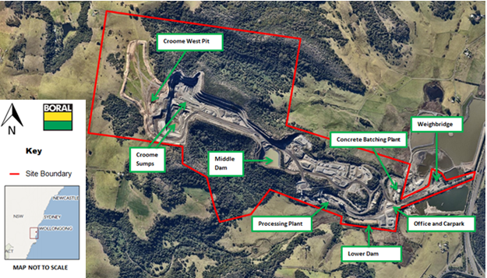
Figure 1 Dunmore Quarry Site Layout

POTENTIAL POLLUTING SUBSTANCES
Table 1 below is an inventory of potential pollutants kept on the premises. This inventory provides a description of the main hazards to human health or the environment, an assessment of the likelihood of the hazards occurring and also includes the current controls and safety equipment and/ or pre-emptive actions in place to minimise or prevent risk of harm to human health or the environment.

Table 1: Inventory of Potential Polluting Substances Initial Assessment (clause98C(1)(d) & (e)
LIST OF POLLUTING SUBSTANCE STORAGES/USES AT SITE: INITIAL ASSESSMENT
(all Chemicals listed in this sheet are to be subjected to a risk assessment located in Appendix A)
Site Name:  Dunmore Quarry |  |  |  |  |  | Responsible Person:  Brodie Bolton |  |  | Date:  24/10/18
Description of Hazard | Covered under Haz Chemicals/MSDS? | Estimated Amount stored (amounts vary depending on operations) | Location of storage | Map reference | Likelihood of Impact on neighbours |  | Current controls/safety equipment  (Pre-emptive Actions) | See Risk Ass & PIRMP Response Action (see Below)
CHEMICALS/FUELS/LUBRICANTS (diesel, Oils, lubricants etc)
Uncontrolled loss of Diesel or other hydrocarbon products that could result in material harm to the environment or human health | Class 3 &  Class 2 | Diesel Storage 54,500L  Waste Oil 3,000L  Packaged Oils 3,000L  Lubricant, gases 3000L | Diesel Storage tank at Go-line and Workshop | Figure 2,3,4,5 and 6, 7 | LOW  Only if substances enter waterways and is transported off-site |  | - Self-bunded tank  - Bunding  - Lined filling area  - PMP  - Training  - Spill Kits  - Flammable Cabinets  - SOP’s  - Inductions  - Fire Fighting Equipment  - Security | Incident #1-3, 4
AIRBOURNE DUST (eg stockpiles, silos, Haul Roads etc)
Excessive airborne dust from stockpiled material, mobile plant or traffic areas causing material harm to the environment or significant impact to community | N/A | Dust Stockpile and haul roads | Dedicated on site stockpile areas | Figure 8,9 | LOW  Only if excessive dust is spread off-site during high winds |  | - Water sprays  - Water Cart  - Maintain manageable levels  - Security  - Reduced speed | Incident #5
AQUEOUS (eg dams, wastewater tanks, other water storage area)
Uncontrolled release of sediment laden water from storage dams causing material harm to the environment | TSS, EC | Lower Dam: 14ML storage capacity  Middle Dam:120ML storage capacity 12ML sediment treatment volume  Croome Sumps:40ML sediment treatment volume 5-10ML. | Lower Dam, Middle Dam and Croome Sumps | Figure 10 | LOW  Only if excessive sediment enters waterways and is transported off-site during significant rain events |  | - Continue to use for dust suppression  - Ensure pumps are maintained through scheduled maintenance  - Discharge monitoring  - Straw Bales  - Rubber and Earthen Berms  - Audits and Inspections | Incident #6
FUMES (substances relating to blast fume from explosives)
Excessive blast fume from blasts causing significant and unexpected impact to the community | N/A | Blast fume containing NOX, SOX | Active production pit area onsite | Figure 11,12 | LOW  Only if explosives are dormant for excessive periods of time and exposed to water during blasting and prevailing winds push fumes towards community |  | - Blast Management Plan  - Procedures  - PMP  - Training  - Don’t sleep shots for excessive periods (ie 7+ days)  - Avoid loading into wet holes | Incident #7

ROLES AND RESPONSIBILITIES
Table 2: Site Personnel Roles and Responsibilities
Position | Responsibility
Employees and Contractors | Following the procedures outlined in the PIRMP and related documents  Immediately alerting Supervisor or Team Leader of any environmental incidents or near-misses.
Team Leaders / Front Line Supervisors | Following the procedures outlined in the PIRMP and related documents (HSEQ MS 3-02)  Immediately alerting Site/Quarry Manager or, in case of their unavailability, Environmental Representative or Environment Manager of any potentially material environmental incidents or near-misses.  Assist in conducting incident investigations
Site / Operations Manager  and/or  Site Environmental Coordinator | Authorisation of the PIRMP  Administration, maintenance and implementation of the PIRMP  Assessing whether the incident is non-trivial and has caused or threatens “material environmental harm” and communicate details to management  Provide direction and advice on incident response  Coordinate communication to neighbours through Stakeholder Relations Manager  Ensuring that investigations are undertaken to a level corresponding to the level of risk and impact.
HSE Regional Manager  and/or  Regional Environment Manager | Make a determination as to whether the incident (as defined in section 147 of the POEO Act) is non-trivial and therefore reportable to external agencies  Inform Executive General manager and Group management of Notification to External Agencies  Undertake notifications as defined in PIRMP  Authorise notifications to public and/or media following GRP-HSEQ-2-02

INTERNAL POLLUTION INCIDENT REPORTING
Any pollution incident satisfying the material harm threshold must be immediately reported to relevant statutory authorities by either the HSE Regional Manager, or Regional Environment Manager.

In cases where “material harm” level cannot be immediately assessed or insufficient information comes to hand on the severity of the incident, the general advice is to err on the side of caution and notify the Relevant Authorities with a qualification that the situation could not yet be fully assessed.

Until further notice the following procedure needs to be followed:
1. When a pollution incident occurs, a person who has become aware of it must immediately bring it to the attention of his/her immediate Supervisor or Manager
2. If necessary, first ring “000” for Emergency Services
3 At least one of the following BCM personnel must be contacted immediately:

Table 3 Key Personnel Contact Information
Name | Function | Phone number | Mobile number
Brodie Bolton | Dunmore Quarry Manager
Chris Brown | Dunmore Production Manager
Stuart McLean | Dunmore Quarry Supervisor
Ben Williams | Environment Coordinator
Rod Johnson | Environment Manager – NSW/ACT
Whilst personal contact details for the following are available in the Controlled on site Pollution Incident Response Management Plan they do not appear in this public document
4. Brodie Bolton or in case of his unavailability one of the Senior Management personnel listed above, is to immediately notify the NSW HSE Regional Manager or Regional Environment Manager
5. NSW HSE Regional Manager to immediately notify all Appropriate Regulatory Authorities specified in Section 9.
6. In borderline situations, where the exceedance of the trigger level of “material harm” of a pollution incident may not be clear, a quick assessment including consultation with Boral environmental personnel should be undertaken to help the decision whether to notify or not.
7. Boral’s Senior Management must be informed promptly of the fact of immediate notification to the Authorities. This includes environmental personnel listed above, as well as James Collins, David Bolton, Greg Price and Scott Carter.

EXTERNAL POLLUTION REPORTING
As the legislation requires that notification must be done immediately upon becoming aware of the pollution incident, it is unlikely that a detailed picture will be available for reporting. Notwithstanding, is seems that some of the Government Authorities prepared a detailed questionnaire which is being filled at the time of this initial notification. Under the stress of incident handling it could be easy to provide a hasty, inaccurate estimate of the situation when answering these questions.
Therefore, the notification should be restricted to the facts known and nothing should be assumed or guessed. The details will be provided to the asking Authority later when more information comes to hand.

The initial notification should include as much of the following information (if known) as possible:
- location and time of the pollution incident;
- type of the incident (spill, fire, unlicensed harmful discharge, etc);
- assessed level of incident gravity: “it seems to be…” (e.g. “a relatively minor spill”, “major fire”, “explosion limited to one building”, etc.);
- whether the Emergency Services have been required to attend.

Unless known for a fact, the answers to other questions should be politely deferred until a better assessment of the situation can be made.

The Boral person who is responsible for notifying the Authorities (NSW HSE Regional Manager or Regional Environment Manager) about the incident must prepare a Notification Log (a suitable form is attached in Appendix C) with the details of time of notifications and the persons who took to the call. The Authorities will generally provide an Incident Notification Number.
Notification of all Appropriate Government Authorities (at least 5 entities) may take considerable time. Delays may be experienced connecting to the right person or no contact may be possible after hours. All such instances should be recorded in the Notification Log.

POLLUTION INCIDENT AUTHORITY CONTACT LIST
Table 4 Pollution Incident Authority Contact List
Government Authority - compulsory notifications | Emergency notification phone number
EPA – Environment Line | 131 555
Fire and Rescue NSW (FRNSW) | 1300 729 579
Shellharbour City Council | 4221 6111
Public Health Unit (South East Sydney / Illawarra AHS)- Wollongong SESI PHU | HealthLink (24 hr)- 0- 1800 063 635  Head Office- Wollongong- 0- 4221 6700
Safework NSW | 131050  Company ABN asked: 51 000 756 507
Government Authority - ring if relevant | Emergency notification phone number
Roads and Maritime Services (road spills) | 132 701
Police & Ambulance | 000
NSW Office of Water | 8838 7885
Bush Fire Control Officer | 1800 049 933
Poisons Information Centre | 131 126
Endeavour Energy (power line emergencies) | 131 003

Communication with the local community may also be undertaken depending on the circumstances of the pollution incident. Appendix B describes in the response action tables the criteria whether an incident may require community notification. If deemed necessary, Dunmore Quarry would consider the following options for providing early warning and ongoing information to the community on pollution incidents:
- Direct phone contact with any local residents directly impacted by the pollution incident using the details in Table 5 below.
- Letter Box drops of incident information and site contacts to local residents impacted by the pollution incident.
- The inclusion of incident details through the routine Community Consultative Committee meetings.
The Stakeholder Relations Manager can assist in the process of communicating with the community, as per the Stakeholder Engagement Plan for the site.
Table 5: Neighbour Notification List
Reference | Contact Name | Address | Contact Details
1 | Jason Maloney
2 | Christine Wood
3 | Alan Pemberton (CCC Croome Member)
4 | Kerry Benny
5 | Margrit Stocker (CCC Swamp Road Member)
6 | Cindy Neaves (CCC Dunmore Lakes Estate Member)
7 | Kathryn Burton (CCC Member
8 | Selwyn Holland (CCC Minnamurra Representative
9 | Denis Renton (CCC Member)
Whilst personal contact details for the following are available in the Controlled on site Pollution Incident Response Management Plan they do not appear in this public document

INCIDENT REPONSE TRAINING
Dunmore Quarry will implement the Pollution Incident Response Management Plan by training or providing information to relevant employees and contractors in relevant areas of the Plan. The nature and objectives of staff training is to relate to site personnel the importance of early notification of any incidents and spills to site supervisors and key personnel.

Training or information will be provided on the following:
- The contents and intent of this PIRMP,
- The roles and responsibilities of site staff in relation to this PIRMP
- Spill response procedures;
- General environmental awareness; and / or
- Hazardous materials awareness.

Site inductions for visitors and sub-contractors also advise individuals to report any environmental incidents or spills to site supervisors and key personnel immediately. Key site personnel and supervisors participate in PIRMP Tests which are used as practical training and can also be used to identify any potential gaps or areas for improvement for the PIRMP. A summary of the PIRMP Drills undertaken at Dunmore Quarry is shown below in Table 6.

Table 6: PIRMP Drills Undertaken at Dunmore Quarry
Test Date | Version of PIRMP tested | Incident Drilled
26/06/19 | V12 | Incident #10 Car park/fuel tank failure
19/10/17 | V10 | Incident #3: Failure of drain valve on bund
04/10/16 | V6 | Incident #5: Excessive airborne dust off stockpile
01/09/15 | V5 | Incident #5: Airborne dust during operations in the afternoon
29/08/14 | V4 | Incident #7: Loss of hydraulic oil from water cart being serviced
30/08/13 | V3 | Incident #2: Loss of fuel while re-fuelling
Please note that V13 of the PIRMP consolidated the incident list. Incident numbers may be reflective of old versions of the PIRMP.
A sign-off sheet is kept of the personnel present for the undertaking of a PIRMP Drill and a record is kept on when and how the PIRMP is communicated to employees. This information forms a section of the PIRMP Drill document.

PIRMP TESTING
Plans must be tested routinely at least once every 12 months. The testing is to be carried out in such a manner as to ensure that the information included in the plan is accurate and up to date, and that each plan is capable of being implemented in a workable and effective manner.
Routine testing of the PIRMP will be conducted annually, and can be completed through the following methods:
- Simulated environmental emergency drills/exercises, or
- Desktop simulations.

PIRMP REVIEW
Revisions are to be coordinated by the Site Manager and Environmental Representative. The objectives of a review are:
- To maintain compliance with the statutory requirements, and
- To identify opportunities for improvement in the Plan, and reduce the risk to human health and the environment.

EVENT BASED
Events which may trigger a review of this Plan or its associated documents include:
- Within 1 month of reporting to the nominated parties in accordance with the plan, after a pollution incident, or
- Modification/Improvement to the system

TIME BASED
Dunmore Quarry will review this management plan routinely every 12 months. The Plan review will include:
- This Document, and
- Legislation, Approval and Licence changes.

APPENDIX A: RISK ASSESSMENT ON POTENTIAL IMPACTS
Table 7 Risk Assessment on Potential Impacts
Hazard and Likelihood Risk Assessment and Corrective Control Measures
Site:  Dunmore Quarry |  |  |  |  |  | Responsible Person:  Brodie Bolton |  | Review Date:  30 October 2018
Name / ref of pollutant/  chemicals | Description of Hazard / Incident leading to hazard | Consequence | Likelihood | Risk | Factors which could increase risk |  | Residual Risk after implementation of controls. (See Table 1 for list of current controls). |  | Responsible person | Action date
Diesel | Incident #1  Uncontrolled loss of Diesel or other hydrocarbon products that could result in material harm to the environment or human health | 1 | 1 | L1 | Dry, windy conditions (increase fire danger) or heavy rain/flood conditions (will increase potential for spill to spread to catchment drainage areas) |  | Consequence: (Minor): Failure resulting in loss of all or substantial volume of tanks would be captured entirely by existing primary bund with no release to soil or water.  Likelihood: (Unlikely): Diesel Tanks are self bunded double walled fuel tanks. Due to location of tank, damage to tanks is unlikely to occur from external equipment. In addition tanks are maintained in good structural integrity with low risk of failure through corrosion. Drain valve, hoses and refuelling equipment are maintained in good structural integrity with low risk of failure The drain valve is locked at all times. |  | As per PIRMP action plan | When required
Airborne dust | Incident #2  Excessive airborne dust from stockpiled material, mobile plant or traffic areas causing material harm to the environment or significant impact to community | 1 | 1 | L1 | Dry, windy conditions (increase wind erosion and dust transport). Summer months with long periods of extended dry conditions. |  | Consequence: (Minor): Excessive dust from stockpile during high winds causing nuisance to surrounding area.  Likelihood: (Unlikely): Stockpiles are maintained to a manageable level on a monthly basis. Use of water sprinklers and water cart onsite during windy periods. Extensive land reserves act as buffer land from surrounding communities. Surrounding land is rural with sparse distribution of neighbours. |  | As per PIRMP action plan | When required
Sediment laden stormwater | Incident #3  Uncontrolled release of sediment laden water from storage dams causing material harm to the environment | 1 | 2 | L2 | Extended periods of rain increase the risk. Late Summer/early Autumn is typically the wettest part of the year on site. |  | Consequence: (moderate): Failure of one or more sediment dams are likely to result in off-site impacts to water courses which would predominantly reduce water quality over a short period of time. As such, impact to the environment/human health is not considered to be significant.  Likelihood: (unlikely): Dams are frequently monitored and inspected for levels and integrity.  Risk Assessment = Moderate Vs Unlikely = L (2)  Note: For PIRMP purposes overflow events during extreme wet weather will be reported under POEO Licence obligations and not Immediate Reporting. |  | As per PIRMP action plan | When required
Blast fume | Incident #4  Excessive blast fume from blasts causing significant and unexpected impact to the community | 1 | 1 | L1 | Windy conditions will increase potential for blast fume to leave site. Excessive periods of sleeping shots (>7 days) loading into wet holes |  | Consequence: (minor): Blast fume would be localised and dispersed with high winds, of short duration and not cause long term impacts.  Likelihood: (unlikely):Blast Management Plan in place to reduce the likelihood of shots being slept for extended periods of time and not loaded into wet holes. |  | As per PIRMP action plan | When required

PART B

PART B: PIRMP RESPONSE ACTIONS AND MAPS
Table 8: Incident #1 Diesel/hydrocarbon Spill Response Actions
Incident #1 | Uncontrolled loss of Diesel or other hydrocarbon products that could result in material harm to the environment or human health. See Figure 2 and 3.  Actions Required:  - Contact all relevant people/department (refer to Immediate Reporting Contact Sheet)  - Ensure bund/liner are capturing full volume of diesel  - Ensure bund integrity is sound throughout the entire period of incident (i.e. periodic inspections)  - Contact service provider (Caltex No. 1800033111 or Transpacific 02 96007185) to pump-out bund contents  - Area to be restricted to Incident Response Personnel  - Ensure spill kit available for any release from bund/liner  - If any release from bund/liner onto unsealed soil/surface water - Environmental Consultants to be engaged to investigate and remediate contamination.  - Repair/replace tanks  - Inspect bund for ongoing serviceability
Alarm raising | Any personnel involved or witnessing incident to report to immediate supervisor and PIRMP actions to be implemented.
Emergency Controller | - Emergency Controller: Quarry Manager or delegate  - Call service provider: Quarry Manager or delegate  - Spill Kit manager: Onsite supervisor or delegate  - Periodic inspections and update reporting of site and bund: Onsite supervisor or delegate
Scale of incident | Incident would be restricted to Diesel storage area with minimal external impact, however, potential for bund/liner overflow or failure may result in soil and surface water contamination that will require specialist investigation/remediation.
Evacuate | Only if fire or explosion potential exists. Quarry Manager and any advice provided by Fire Department as part of attendance after immediate notification.
Communications | Internal:  - Quarry Manager or delegate to use contact sheet for all internal (Boral) contacts  External mandatory:  - Immediate Reporting Contact Sheet to be used  External non-mandatory:  - Contact Neighbours 5,6,7 and 8 only if diesel has escaped into storm-water drainage lines and will enter Rocklow Creek. See Table 5 Section 11 for the Neighbor Notification List.
Rescuer / respondent + safety checks | As per Site Emergency Plan or Fire Department as part of Immediate Reporting
Rescue + First Aid | As per Site Emergency Plan or Fire Department as part of Immediate Reporting
Clean up and  Waste disposal | Service Provider to dispose of diesel and advise on required clean-up.
Reporting and re-preparedness | See HSEQ MS:  - Incident Reporting, Investigation and Action Management Standard (GRP-HSEQ 3-02)

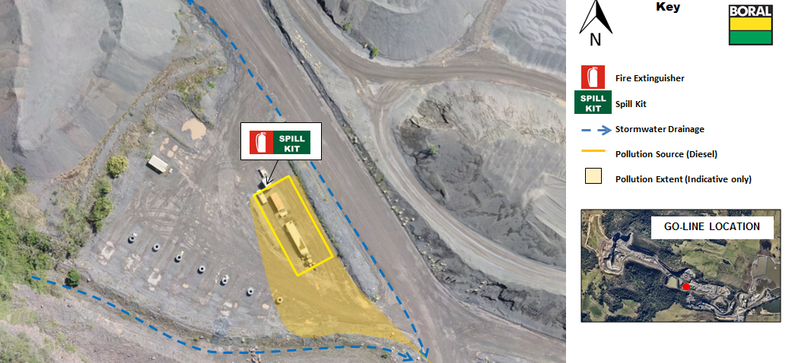
Figure 2: Go-line Above Ground Diesel Storage Area
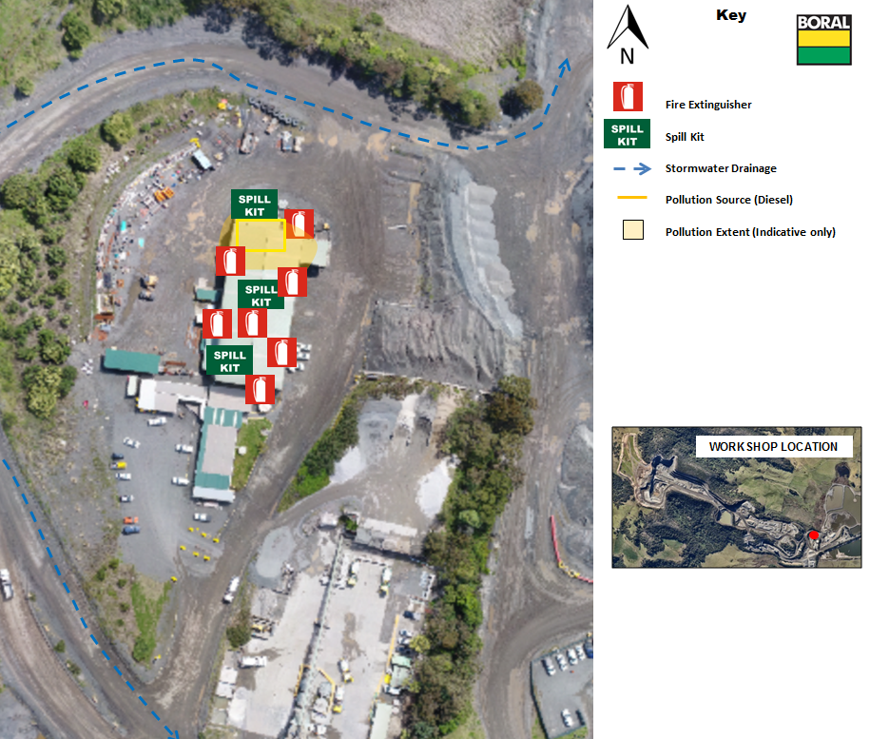
Figure 3: Workshop Diesel/hyrocarbon Storage Area

Table 9: Incident #2: Excessive Airborne Dust Response Actions
Incident #2 | Excessive airborne dust from stockpiled material, mobile plant or traffic areas causing material harm to the environment or significant impact to community. See Fig 4 & 5.  Actions Required:  - Employees, Contractor/Visitor to notify site representative of issue immediately.  - Dust suppression activity to commence immediately on stockpiles via water cart or other means. Any operations associated with disturbing the stockpiles, such as driving and dumping on, to be minimised or ceased.  - Daily monitoring to be undertaken to assess weather and site conditions  - Contact all relevant people/department (refer to Immediate Reporting Contact Sheet)
Alarm raising | Any personnel involved or witnessing incident to report to immediate supervisor and PIRMP actions to be implemented.
Emergency Controller | - Emergency Controller: Quarry Manager or delegate  - Call service provider: Quarry Manager or delegate  Periodic inspections and update reporting of site and stockpiles: Onsite supervisor or delegate
Scale of incident | Incident would be localised to the area surrounding stockpile area, with minimal external offsite impact.
Evacuate | Only if fire or explosion potential exists. Quarry Manager and any advice provided by Fire Department as part of attendance after immediate notification.
Communications | Internal:  - Brodie Bolton - Quarry Manager  - Rod Johnson &/or Ben Williams – Enviro Representative  External mandatory:  - Immediate Reporting Contact Sheet to be used  External non-mandatory:  - Contact neighbors affected (will be dependent on wind direction). The environmental representative is to be consulted as to which neighbours will be affected by a particular wind direction. See Table 5 Section 11 for the Neighbor Notification List.
Rescuer / respondent + safety checks | As per Site Emergency Plan or Fire Department as part of Immediate Reporting
Rescue + First Aid | As per Site Emergency Plan or Fire Department as part of Immediate Reporting
Clean up and  Waste disposal | All water carts to be placed on areas producing airborne dust. If necessary work must be ceased to control airborne dust. No disposal of waste required.
Reporting and re-preparedness | See HSEQ MS:  - Incident Reporting, Investigation and Action Management Standard (GRP-HSEQ 3-02)

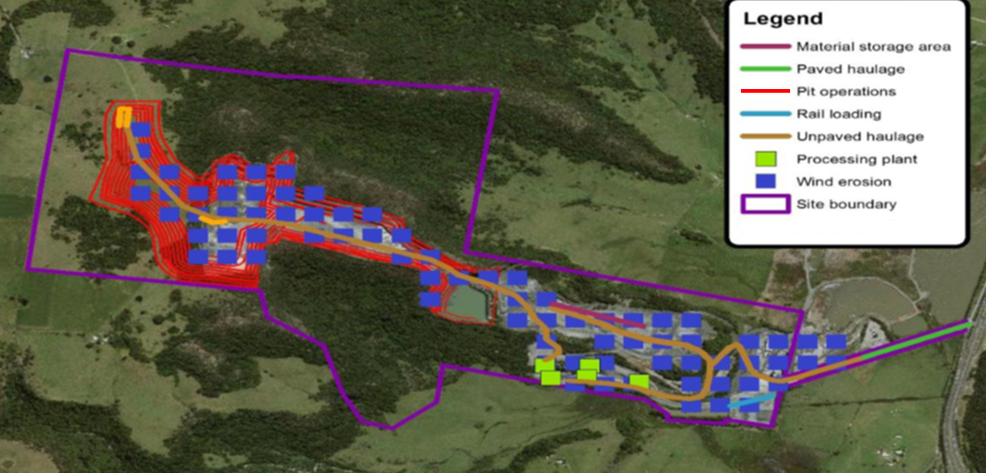
Figure 4: Sources of Dust Pollution at Dunmore Quarry
Please note that pollution controls include operational response which is not included on these maps. See Table 1 in Section 7 for more detail on pollution controls for Incident #2.
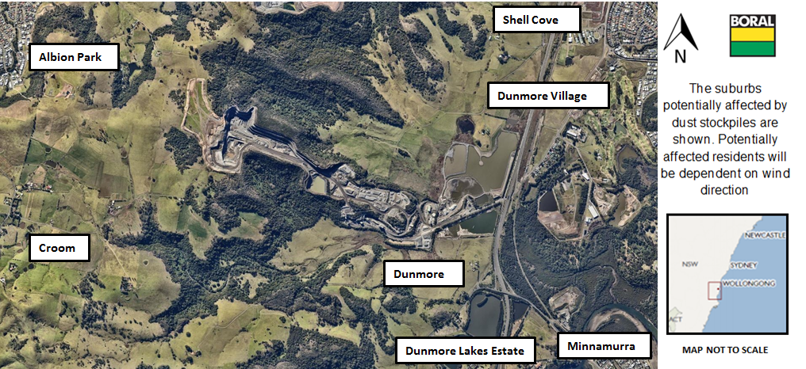
Figure 5: Potential Suburbs Affected by Dust Emissions under Adverse Conditions

Table 10: Incident #3: Uncontrolled Release of Stormwater Response Actions
Incident #3 | Uncontrolled release of sediment laden water from storage dams causing material harm to the environment. See Fig #6  Actions Required:  - Contact all relevant people/department (refer to Immediate Reporting Contact Sheet)  - Ensure bund integrity is sound throughout the entire period of incident (i.e. periodic inspections)  - Contact local neighbours if going to be in inundated by rise of water  - Area to be restricted to Incident Response Personnel  - If any release from site onto unsealed soil/surface water - Environmental Consultants to be engaged to investigate and remediate contamination,if any  - Contact local contractor to rebuild dams immediately
Alarm raising | Any personnel involved or witnessing incident to report to immediate supervisor and PIRMP actions to be implemented.
Emergency Controller | - Emergency Controller: Quarry Manager or delegate  - Call service provider: Quarry Manager or delegate  - Spill Kit manager: Onsite supervisor or delegate  - Periodic inspections and update reporting of site and bund: Onsite supervisor or delegate
Scale of incident | Catastrophic failure of one or more sediment dams are likely to result in off-site impacts to water courses which would predominantly reduce water quality over a short period of time. As such, impact to the environment/human health is not considered to be significant.
Evacuate | Only if flood potential exists. Quarry Manager and any advice provided by Fire Department as part of attendance after immediate notification.
Communications | Internal:  - Quarry Manager or delegate to use contact sheet for all internal (Boral) contacts  External mandatory:  - Immediate Reporting Contact Sheet to be used  External non-mandatory:  - Contact Neighbours 5,6,7 and 8 in the case of a sediment dam failure affecting water quality downstream over an extended period of time. See Table 5 Section 11 for the Neighbor Notification List.
Rescuer / respondent + safety checks | As per Site Emergency Plan or Fire Department as part of Immediate Reporting
Rescue + First Aid | As per Site Emergency Plan or Fire Department as part of Immediate Reporting
Clean up and  Waste disposal | Depending on severity of incident, consultants to be contacted to advise on required clean-up.
Reporting and re-preparedness | See HSEQ MS:  - Incident Reporting, Investigation and Action Management Standard (GRP-HSEQ 3-02)

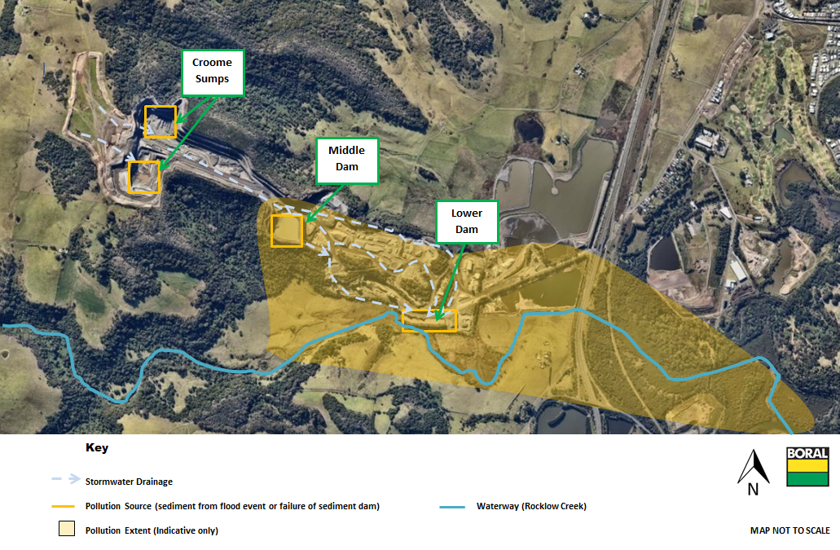
Figure 6: Overflow of Sediment Dams due to Flooding or Dam Failure
Please note that pollution controls include inspections and operational response which are not showed on these maps. See Table 1 in Section 7 for more details.

Table 11: Incident #4: Excessive Blast Fume Response Actions
Incident #4 | Mobile plant, hydraulic hose or fuel tank failure causing material harm to the environment  Actions Required:  - Contractor/Visitor/Employee to notify site representative of issue immediately. (induction)  - Contact all relevant people/department (refer to Immediate Reporting Contact Sheet)  - Area to be restricted to Incident Response Personnel  - If any release from site into surrounding community - Environmental Consultants to be engaged to investigate  - Call service provider, Orica, to provide advice and assistance in incident
Alarm raising | Any personnel involved or witnessing incident to report to immediate supervisor and PIRMP actions to be implemented.
Emergency Controller | - Emergency Controller: Quarry Manager or delegate  - Call service provider: Quarry Manager or delegate  - Periodic inspections and update reporting of offsite impacts: Onsite supervisor or delegate
Scale of incident | Incident would be localised to the area with no long term impact.
Evacuate | Only if fire or explosion potential exists. Quarry Manager and any advice provided by Fire Department as part of attendance after immediate notification.
Communications | Internal:  - Quarry Manager or delegate to use contact sheet for all internal (Boral) contacts  External mandatory:  - Immediate Reporting Contact Sheet to be used  External non-mandatory:  - Contact Neighbours 1,2,3,4 and 5 only if blast fumes is migrating offsite towards neighbours. See Table 5 Section 11 for the Neighbor Notification List.
Rescuer / respondent + safety checks | As per Site Emergency Plan or Fire Department as part of Immediate Reporting
Rescue + First Aid | As per Site Emergency Plan or Fire Department as part of Immediate Reporting
Clean up and  Waste disposal | Service Provider to provide advice on clean up
Reporting and re-preparedness | See HSEQ MS:  - Incident Reporting, Investigation and Action Management Standard (GRP-HSEQ 3-02)

Figure 7: Potential impacted areas due to excessive Blast fume
Please note that prevailing winds in the Dunmore Quarry area are typically from the North east. Blowing towards to Croome Farm area of the site.

PART B: POLLUTION INCIDENT NOTIFICATION LOG
Person undertaking notification (Name/Function):
Date and time when first become aware of the incident:
Incident type:
Comments:

Initial immediate notification log
Appropriate Regulatory Authority | Time of call | Respondent’s name/function |  | Approximate call duration | Comments
EPA
Public Health Unit
Fire and Rescue NSW
Local Council
Safework NSW
Other: (including neighbours)
Other: (including neighbours)
Other: (including neighbours)
Other: (including neighbours)
Other:
Summary of initial communication:

Person undertaking notification (Name/Function):
Date and time when additional information become available:
Comments:

Immediate notification of further pertinent information (if applicable)
Appropriate Regulatory Authority | Time of call | Respondent’s name/function | Approximate call duration | Comments
EPA
Public Health Unit
Fire and Rescue NSW
Local Council
WorkCover
Other:
Other:
Summary of additional communication

APPENDIX D: IMMEDIATE NOTIFICATION SHEET
Table 17: Internal Reporting List
Name | Function | Phone Number | Mobile Number
Brodie Bolton | Dunmore Quarry Manager
Chris Brown | Dunmore Quarry Production Manager
Stuart McLean | Dunmore Quarry Production Supervisor
Ben Williams | Dunmore Quarry Environmental Coordinator
Rod Johnson | Environment Manager (NSW/ACT)
Whilst personal contact details for the following are available in the Controlled on site Pollution Incident Response Management Plan they do not appear in this public document

Table 18: External Reporting List
Government Authority – compulsory notifications | Emergency notification phone number
EPA – Environment Line | 131 555
Fire and Rescue NSW (FRNSW) | 1300 729 579
Shellharbour City Council | 02 4221 6111
Public Health Unit (South East Sydney / Illawarra AHS) – Wollongong SESI PHU | HealthLink (24 hr) - 0 - 1800 063 635  Head Office – Wollongong - 0- 4221 6700
Safework NSW | 131050 Company ABN asked: 51 000 756 507
Government Authority – contact if relevant | Emergency notification phone number
Roads and Maritime Services (road spills) | 132 701
Police and Ambulance | 000
NSW Office of Water | 02 8838 7885
Bushfire Control Officer | 1800 049 933
Poisons Information Centre | 131 126
Endeavour Energy (power line emergencies) | 131 003

Table 19: Neighbour Notification List
Neighbour Notification List (contact if relevant)
Reference | Contact Name | Address | Contact Details
1 | Jason Maloney
2 | Christine Wood
3 | Alan Pemberton (CCC Croome Member)
4 | Kerry Benny
5 | Margrit Stocker (CCC Swamp Road Member)
6 | Cindy Neaves (CCC Dunmore Lakes Estate Member)
7 | Kathryn Burton (CCC Member
8 | Selwyn Holland (CCC Minnamurra Representative

Section/Clause | Requirement | Location in PIRMP
98C(1) (d) | An inventory of potential pollutants on the premises or used in carrying out the relevant activity | Table 1: Inventory of Potential Pollutants
98C(1) (e)

