Pollution Incident Response Management Plan

Boral Cement Prestons

October 2019

General Information

Foreword

This document was prepared to fulfil the requirements of the NSW Protection of the Environment Legislation Amendment Act 2011 (POELA Act) in terms of preparation and implementation of a pollution incident response management plan.

This plan forms a part of the overall Boral Emergency Response Plan that was reviewed and amended to ensure that they cover all the new requirements of the POELA Act. The plan is kept, tested and implemented in accordance with the Act and the POEO (G) Regulation.

Background and legislative requirements

The POELA Act introduces several changes to improve the way pollution incidents are reported, managed and communicated to the general community. The Act includes a new requirement under Part 5.7A of the Protection of the Environment Operations Act 1997 (POEO Act) to prepare, keep, test and implement a pollution incident response management plan.
The objectives of these plans are to:

- ensure comprehensive and timely communication about a pollution incident to staff at the premises, the Environment Protection Authority (EPA), other relevant authorities specified in the Act (such as local councils, NSW Ministry of Health, WorkCover NSW, and NSW emergency services) 1 and people outside the facility who may be affected by the impacts of the pollution incident

- minimise and control the risk of a pollution incident at the facility by requiring identification of risks and the development of planned actions to minimise and manage those risks

- ensure that the plan is properly implemented by trained staff, identifying persons responsible for implementing it, and ensuring that the plan is regularly tested for accuracy, currency and suitability.

The specific requirements for pollution incident response management plans are set out in Part 5.7A of the POEO Act and the Protection of the Environment Operations (General) Regulation 2009 (POEO(G) Regulation)1.

Definition of a pollution incident

As per the POEO Act, pollution incident means an incident or set of circumstances during or as a consequence of which there is or is likely to be a leak, spill or other escape or deposit of a substance, as a result of which pollution has occurred, is occurring or is likely to occur. It includes an incident or set of circumstances in which a substance has been placed or disposed of on premises, but it does not include an incident or set of circumstances involving only the emission of any noise.

A pollution incident is required to be notified if there is a risk of ‘material harm to the environment’, which is defined in section 147 of the POEO Act as:

1 See www.environment.nsw.gov.au

- harm to the environment is material if:

  - it involves actual or potential harm to the health or safety of human beings or to ecosystems that is not trivial, or

  - it results in actual or potential loss or property damage of an amount, or amounts in aggregate, exceeding $10,000 (or such other amount as is prescribed by the regulations), and

- loss includes the reasonable costs and expenses that would be incurred in taking all reasonable and practicable measures to prevent, mitigate or make good harm to the environment.

Industry is now required to report pollution incidents immediately to the EPA, NSW Health, NSW emergency services, WorkCover NSW and the local council. ‘Immediately’ has its ordinary dictionary meaning of promptly and without delay. These strengthened provisions will ensure that pollution incidents are reported directly to the relevant response agencies so they will have direct access to the information they need to manage and deal with the incident in a faster time.

There are new associated offences, for individuals and corporations, for not preparing a plan, not keeping the plan at the premises to which it relates, not testing the plan in accordance with the Regulations and not implementing the plan in the case of an incident.

Risk Assessment and Preventive Actions

Potential Site Risks

Potential environmental pollutants are summarised in a site risk register entitled “Environment Aspects and Impacts” (CMT-ENV-002- Prestons Environmental Aspects and Impacts Register) (see appendix C). This document considers; Aspect, Impact, Controls and Improvements for the sites known environmental hazards in the following areas:

    - Fugitive dust emissions from plant areas
    - Spills of liquids (e.g. diesel, oil) or powdered solid materials (e.g. cement), potentially leaving the site. Large spill of powdered solids may result in significant dust nuisance or lead to deposition of significant quantities of high pH particulate matter in the natural water bodies.no Chemical goods stored onsite spill would be only from Vehicles/Silos
    - Explosion and fire/smoke.
.

Harm Reduction

Spill Prevention (liquids and solids):

The risk of harm to any persons who are on the premises or who are present where the scheduled activity is being carried out is reduced by measures outlined in Boral Cement Corporate SOP “CEM-ENV-014 Spill Prevention and Control”. These measures include:

- Placement of spill-risk facilities away from sensitive environments (sufficient to allow for effective intervention prior to pollution occurring in the event of a spill)

- Use of secondary spill containment facilities such as bunding around all storage tanks and other areas where hazardous substances are stored;

- Ensuring that areas where risky activities such as storage tank/silo loading are undertaken are bunded and sealed;

- Avoiding risky activities at times when weather events may magnify the harm caused by a spill;

- Ensuring drainage structures can be sealed to halt passage of spilt fluids or powdered solids;

- Training of employees and contractors in good environmental practice.

The bunded areas must be capable of preventing the migration of any spillage or leakage to the surrounding environment. The requirement for bunding is relative to the level of risk and type of area. Bunding specifications are summarised in Australian Standard AS 1940:2004.

Maintenance:

All silos, tanks and pipe-work are inspected regularly and at least annually for signs of damage. Any defect in the walls or lining is repaired immediately using appropriate techniques. Damage to the tank or transfer hoses is dealt with immediately to prevent failure.

Any spilt liquid or powdered solid material must be promptly cleaned up in an appropriate manner – usually as contaminated matter.

Do not allow spilt liquid or stormwater to remain in the bund – it may accumulate and lead to overflowing. Rainwater entering the sump or bunded area should be regarded as potentially contaminated and must be disposed of in an authorised manner.

Safety Equipment

The site utilises portable Oil and Petroleum Response Kit 190L. The bag’s contents include:

    - 1 x Spill response procedures.
    - 1 x 240L Wheelie bin.
    - 2 x Safety spectacles.
    - 2 x Pairs of Solvent and oil resistant gloves.
    - 2 x Disposable overalls, white XL.
    - 2 x Disposable respirators ALP2
    - 2 X T280 Sorbent double booms, 10 x23cm x3m, 38L. o 2 x P-FL550DD Folded sorbent rolls, 45cm x 15m, 40L. o 5 x Yellow Contaminated Waste bags.
    - 25 x HP-156 Sorbent pads, 43 x 48cm, 1.4L.

Fire protection system on site is addressed in the Emergency Response Plan. The types of fire extinguishers used on site are appropriate for their application.

2.4 Site Maps

The Google photo (Figure 1) shows the location of the premises to which the licence relates, with the surrounding area that is likely to be affected by a pollution incident. All immediate neighbouring premises are of industrial nature.

The site layout is presented in Figure 2.

Stormwater runoff water is managed through a concrete drainage. Further details are described in Prestons Environmental Management Plan (Fly Ash & Cement Silos Operation)

Figure 1 - Site location

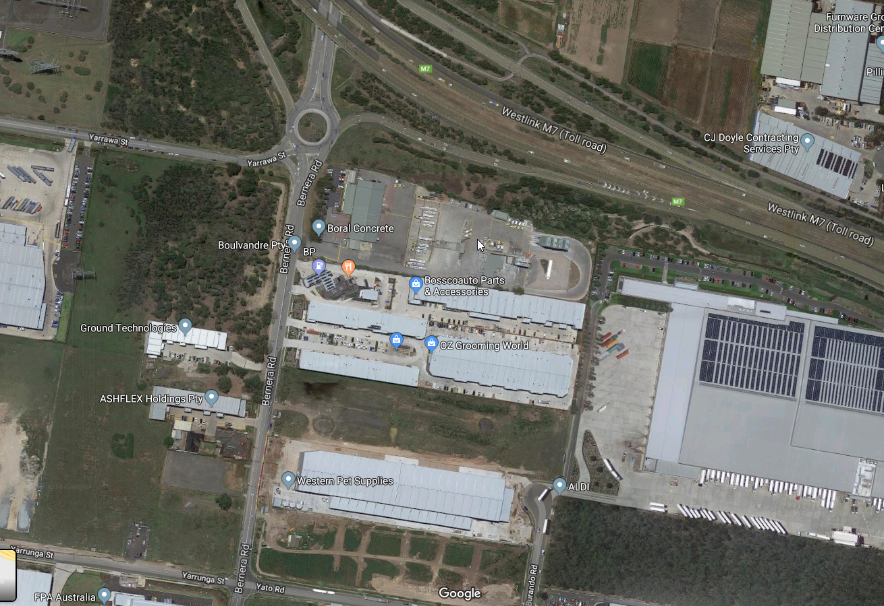

Figure 2. Site diagram

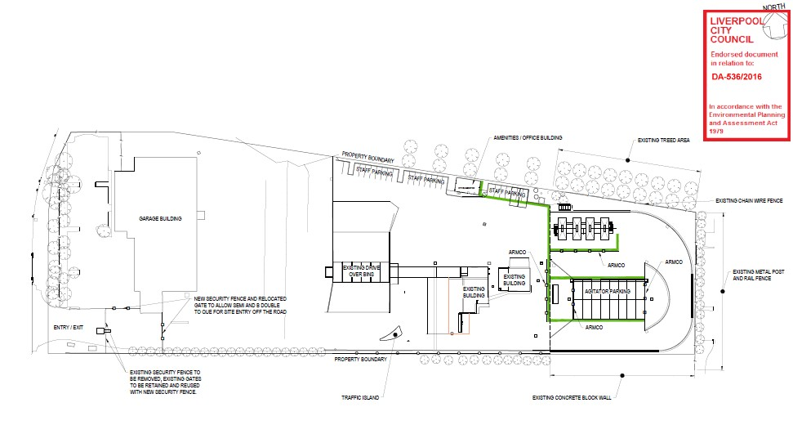

Early Notifications

Immediate Notification of Government Authorities

Any pollution incident that causes or threatens “material harm” to the environment or people must be notified to government authorities immediately upon becoming aware of the incident. When new information comes to hand following the initial notification, this information must also be communicated immediately. For the definition of “material harm” caused by a pollution incident refer to Section 1.2.

“Immediately” means “without unreasonable delay”. Remember, safety first.

Only nominated Boral personnel are authorised to make notifications to the Authorities:

Brian Soper | Site Manager, Prestons |  | 0401 892 630
Bruce Latham | HS Manager (Cement) |  | 0401 893 358
Belinda Prideaux | Environment Business Partner: (Cement) |  | 0401 893 359
Norm Azar | Production Manager – Concrete (Sydney West) |  | 0401 895 714

All notifications are to be in line with Boral standard operation procedure for incident notification CMT-ENV- 001 –Incident Notification, located in WizBiz Reference Library.

The contact list of Compulsory Authorities is presented in Appendix A. Other Authorities may need to be notified as appropriate; however the Compulsory Authorities must be notified in ALL cases requiring

environmental notification. All immediate notifications and updates are to be recorded in the Pollution Incident Immediate Notification Log.

In borderline situations, where the exceedance of the trigger level of “material harm” of a pollution incident may not be clear, a quick assessment including consultation with Boral environmental personnel should be undertaken to help the decision whether to notify or not.

Boral’s Senior Corporate Management must be informed promptly of the fact of immediate notification to the Authorities. This includes environmental personnel listed above, Jim Young, Bruce Latham, Greg Johnson and Scott Carter.

Notification of Neighbours

In case of pollution incidents that may potentially pose threat to the health and safety of the neighbours (e.g. toxic fumes, fire, fuel spill into the street, release of a thick dust cloud, etc.), the neighbours must also be urgently notified.

The early warning of the neighbourhood notification will be undertaken by site staff by phone. The current contact list for neighbours is attached in Appendix B. The initial notification should be brief and contain only a description of the environmental threat together with instructions what to do. For example:

- Due to a dust collector’s failure in the bag shed, we are experiencing elevated dust emissions from the site. Please keep your doors and windows closed until further notice.
- An accidental trade effluent discharge occurred from the site to a local creek. Please refrain from recreational use of the area until testing confirms that the water is safe.
- Due to a diesel spillage onto a street from the site, a clean-up operation is being organised. Please be watchful for road closures in relation to this operation.

A follow up information on the resolution of emergency situation would be timely conducted on the phone.

Pollution Incident Emergency Response

In the event of a pollution incident the risk of harm to human health will be minimised by engaging an appropriate pollution response as outlined below

- Stop the source: If it‘s safe to do so, stop the process causing the spill/leak or other environmental incident.

- Isolate the area: The first person to notice the spill or leak should remove themselves from the immediate area and take measures such as barricading the area to reduce the risk of exposure to others. This must occur without exposure to danger.

- Commence early notification: The Manager or Supervisor must be notified immediately of the environmental incident. They in turn must immediately inform one of the persons nominated for notification of Authorities (see Appendix A). If the environmental incident is significant, the nominated person implements early notification procedures to the relevant Authorities including emergency services. Alerting the potentially affected neighbours may also be required (see Appendix B), with regular updates provided as needed.
- Provide a 1st aid response (if required): First aid kit including a trauma pack and instruction for use is located in the lunch room. Emergency shower is available in the blending shed, near the door. Eye wash is located in the lunch room. Appropriate PPE is worn by all staff during periods of potential exposure as outlined in relevant MSDS.

- Identify the release to the greatest extent possible: Do so without being at risk. This includes identifying:

  - The type of material released, e.g.
    - Class 2 Gases - compressed, liquefied or dissolved under pressure.
    - Class 3 Flammable Liquids
    - Solid material spill.
  - The label and Material Safety Data Sheet for the product should give information on safe clean-up.
  - The size of the release and whether the release has stopped;
  - Whether chemicals involved may be potentially incompatible; and
  - Any unusual features such as foaming, odour, smoke, etc.

- Determine the level of emergency: review chemical risk assessments, seek internal advice from area specialists, review MSDS’s and seek professional advice from the fire brigade and/or hazardous material specialists.

- Determine if evacuation is required and consider the impact that wind, rain, local geographical features such as hills and stormwater drainage systems may have in exposing persons at emergency assembly points. If in doubt commence evacuation to “cold zones” Following a Pollution / Hazardous Material Incident the Emergency Site is to be divided into Hot, Warm and Cold Zones - for management purposes. The Site Manager (or Weighbridge Operator if not present) is responsible for the management of the COLD ZONE, all personnel are to be evacuated from the hot/warm zone.

Hot Zone This is the area of likely contamination. Only personnel wearing the appropriate level of protective clothing and equipment are to enter this zone. The area of the Hot Zone is defined, controlled and co-ordinated by the Hazmat Controller (FIRE BRIGADE).

Warm Zone This is the area immediately surrounding the Hot Zone where decontamination takes place and personnel and equipment are prepared for deployment. Only personnel wearing the appropriate level of protective clothing and equipment are to enter this zone. The area of the Warm Zone is defined, controlled and co-ordinated by the Hazmat Controller (FIRE BRIGADE).

Cold Zone This is the area immediately surrounding the warm zone. It is the support area where access is limited to support agencies personnel and equipment. This zone contains the Site Control, triage and treatment facilities and other marshalling and assembly areas. The Cold Zone is free of contamination and personnel protective clothing is not required. The area of the cold zone is defined by the site controller in consultation with the Hazmat Controller and managed by the Site Manager (or Weighbridge Operator if not present).
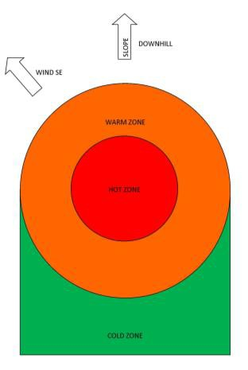

8. Stop further release (if not done prior): prevent further release by isolating the source of the release. (Trained personnel only with suitable PPE)

Stop the release from spreading (if safe to do so):

  - Prevent off-site release of contaminated stormwater: Protect stormwater grates with booms, covers or drain socks.
  - Liquid spills: Deploy spill kits to prevent further contamination dispersal, using appropriate absorbent/containment materials such as loose absorbent, socks or pads (land) and booms (water). See also CEM-ENV-014 Spill Prevention and Control.
  - Powdered solid spills: Lower down the silo rolling doors to minimise dust, cover stormwater grates to prevent ingress of solids.
  - Releases of pollutants into the air: Shut down ventilation systems to keep gases, vapours and dust from spreading.

- Large spills: Summon specialist spill emergency response contractors (e.g. Transpacific Industrial Solutions, 1800 SPILLS).

- Fire: If possible, endeavour to prevent fire-fighting water from entering the stormwater drains as it typically carries contamination. If possible, divert fire from areas containing materials that may generate toxic fumes when burned (e.g. stores of chemicals, cleaning aids, motor oil, etc.).

Dispose of contaminated spill clean materials and wastes using a licensed contractor.

- If required, remediate the site.

ALERT WEIGHBRIDGE,

BRIAN SOPER

EARLY NOTIFICATION
EMERGENCY RESPONSE

IMMEDIATELY CONTACT BORAL CEMENT MANAGEMENT

PROVIDE 1ST AID ENSURE SAFETY OF OTHERS
BRIAN SOPER

BELINDA PRIDEAUX

OR
GREG JOHNSON

IMMEDIATE NOTIFICATION OF AUTHORITIES

  - EPA – ENVIRONMENT LINE

  - FIRE & RESCUE NSW

  - LIVERPOOL COUNCIL

  - WORKCOVER

  - PUBLIC HEALTH UNIT LIVERPOOL

  - OTHER AS APPROPRIATE

IDENTIFY THE SPILL/RELEASE

- The type of material released;

- The size of the release and whether it has stopped;

- Whether potentially incompatible chemicals are involved

- Any unusual features such as foaming, odour, smoke, etc.

- Discuss with hazardous material specialist / Fire Brigade

- Review MSDS

COMPLETE NOTIFICATION LOG

CMT-ENV-001

CONTAIN THE SPILL / PREVENT FURTHER RELEASE

(If safe and if trained to do so)

Boral Cement Prestons

Pollution Incident Emergency Response Plan U

Page 9 of 15

Uncontrolled if printed 18/10/19

INFORM SENIOR BORAL MANAGEMENT:
DETERMINE “COLD ZONE”

JIM YOUNG /JAMES CAMPBELL

RESTRICT ENTRY TO WARM & HOT ZONES

Chief Warden to determine

IF ALERTING THE NEIGHBOURS is re
Chief Warden to determine IF EVACUATION is required

RECEPTION TO ALERT THE NEIGBOURS BY PHONE
SUMMON EMERGENCY CLEANUP CONTRACTORS

Transpacific, 1800 SPILLS

CONTACT LIST - REFER APPENDIX B

REMEDIATE

- Training and testing

The Emergency Planning Committee will be responsible for training and testing the content of the emergency response (including Pollution Incident Management Plan) annually. Pollution incident testing will be undertaken within 1 month of any pollution incident occurring in the course of an activity to which the licence relates so as to assess, in the light of that incident, whether the information included in the plan is accurate and up to date and the plan is still capable of being implemented in a workable and effective manner.

Staff training is recorded in the Training Matrix.

Emergency Response Plan is reviewed annually through a consultation process. Testing schedule and drill log are maintained in the Emergency Response folder at the Weighbridge.

This PIRMP was last tested on:

Revision History

Version | Change Date | Summary of Change | Prepared by | Approved By
Rev.1 | 23/02/17 | Final draft approved | Belinda Prideaux | Belinda Prideaux
Rev.2 | 20/08/18 | Review | Ed Richardson | Belinda Prideaux
Rev.3 | 20/05/19 | Review | Ed Richardson | Belinda Prideaux
Rev.4 | 18/10/19 | Review | Belinda Prideaux | Greg Johnson

APPENDIX A: Immediate Pollution incident Notification - Authority Contacts

GOVERNMENT AUTHORITY - COMPULSORY NOTIFICATIONS | EMERGENCY NOTIFICATION PHONE NUMBER
EPA – Environment Line | 131 555
Fire & Rescue NSW | 0 - 1300 729 579
Liverpool City Council | 1300 36 2170
Public Health Office -Liverpool | 02 87780855  Ask for Public Health Officer on call
WorkCover Authority of NSW | 131050  Company ABN asked: 62 008 528 523
GOVERNMENT AUTHORITY - RING IF RELEVANT | EMERGENCY NOTIFICATION PHONE NUMBER
Roads and Maritime Services | 132 701
NSW Office of Water | 8838 7885
Bush Fire Control Officer | 1800 049933
Poisons Information Centre | 131 126

APPENDIX B: Neighbours Contact List - Prestons

NEIGHBOURS | ADDRESS | EMERGENCY NOTIFICATION PHONE NUMBER | METHOD
Pie Face BP Service Station | 14 Bernera Rd, Prestons NSW 2170 | 0433 999 222 | Phone
BP Service Station | 14 Bernera Rd, Prestons NSW 2170 | 0433 999 222 | Phone
Aldi | 10-12 Bernera Rd,  Prestons NSW 2170 | 13 25 35 | Phone

