Pollution Incident
Response Management Plan
(Part of Site Emergency Response Plan)

Boral Cement Maldon

Rev.7
May 2019

Table of Contents
(part of Site Emergency Response Plan) 1
1. General Information 3
1.1 Foreword 3
1.2 Background and legislative requirements 3
2. Risk Assessment and Preventive Actions 4
2.1 Environmental Registers 4
2.2 Harm Reduction 5
2.2.1 Prevention 5
2.2.2 Maintenance 6
2.2.3 Site Maps 6
2.2.4 Safety Equipment 7
3. Early Notifications 11
3.1 Immediate Notification of Government Authorities 11
3.2 Notification of Neighbours 11
4. Pollution Incident Emergency Response 12
5. Training and Testing 16
6. Revision History 16
APPENDIX A: Pollution Incident Authority Notification Contacts 17
APPENDIX B: Bulk Storage 18

- General Information
  - Foreword
This document was prepared to fulfil the requirements of the NSW Protection of the Environment Legislation Amendment Act 2011 (POELA Act) in terms of preparation and implementation of a pollution incident response management plan.
This plan forms a part of the overall Boral Emergency Response Plan that was reviewed and amended to ensure that they cover all the new requirements of the POELA Act. The plan is kept, tested and implemented in accordance with the Act and the POEO (G) Regulation.

  - Background and legislative requirements
The POELA Act introduces several changes to improve the way pollution incidents are reported, managed and communicated to the general community. The Act includes a new requirement under Part 5.7A of the Protection of the Environment Operations Act 1997 (POEO Act) to prepare, keep, test and implement a pollution incident response management plan.
The objectives of these plans are to:
- ensure comprehensive and timely communication about a pollution incident to staff at the premises, the Environment Protection Authority (EPA), other relevant authorities specified in the Act (such as local councils, NSW Ministry of Health, WorkCover NSW, and NSW emergency services) 1 and people outside the facility who may be affected by the impacts of the pollution incident
- minimise and control the risk of a pollution incident at the facility by requiring identification of risks and the development of planned actions to minimise and manage those risks
- ensure that the plan is properly implemented by trained staff, identifying persons responsible for implementing it, and ensuring that the plan is regularly tested for accuracy, currency and suitability.
The specific requirements for pollution incident response management plans are set out in Part 5.7A of the POEO Act and the Protection of the Environment Operations (General) Regulation 2009 (POEO (G) Regulation).

Definition of a pollution incident
As per the POEO Act, pollution incident means an incident or set of circumstances during or as a consequence of which there is or is likely to be a leak, spill or other escape or deposit of a substance, as a result of which pollution has occurred, is occurring or is likely to occur. It includes an incident or set of circumstances in which a substance has been placed or disposed of on premises, but it does not include an incident or set of circumstances involving only the emission of any noise.
A pollution incident is required to be notified if there is a risk of ‘material harm to the environment’, which is defined in section 147 of the POEO Act as:

(a) harm to the environment is material if:
(i) it involves actual or potential harm to the health or safety of human beings or to ecosystems that is not trivial, or
(ii) it results in actual or potential loss or property damage of an amount, or amounts in aggregate, exceeding $10,000 (or such other amount as is prescribed by the regulations), and
(b) loss includes the reasonable costs and expenses that would be incurred in taking all reasonable and practicable measures to prevent, mitigate or make good harm to the environment.
Industry is now required to report pollution incidents immediately to the EPA, NSW Health, NSW emergency services, WorkCover NSW and the local council. ‘Immediately’ has its ordinary dictionary meaning of promptly and without delay. These strengthened provisions will ensure that pollution incidents are reported directly to the relevant response agencies so they will have direct access to the information they need to manage and deal with the incident in a faster time.
There are new associated offences, for individuals and corporations, for not preparing a plan, not keeping the plan at the premises to which it relates, not testing the plan in accordance with the Regulations and not implementing the plan in the case of an incident.

- Risk Assessment and Preventive Actions
  - Environmental Registers
Maldon has a Hazardous Substances and Dangerous Goods Register 047-F02 located at; http://dcmald01/sites/wizbizmaldon/HealthandSafety/RiskManagement/RiskhazardRegisters/HazardRegister/Shared%20Documents/04-01-A09%20Maldon%20Site%20Risk%20Register.xls. The register contains the maximum quantity of any pollutant that is likely to be stored or held onsite. The site has reviewed quantities of Hazardous substances onsite against placard and manifest requirements. All Hazardous substances are below manifest requirements and have appropriate placards.
Each Hazardous Substance/Dangerous good has an associated safety Data Sheet which contains a description of the hazards to both human health and the environment. A current register of MSDS’s are available through the intranet application; Chem Alert http://vabndc09:8080/chemalert/ and available in hard copy in the Lab. Safety data sheets are displayed in all areas which use or store products of this nature. Supporting signposting is also displayed where required.
In addition to Hazardous substances / Dangerous goods; potential environmental risks are listed in a risk register “CMT-ENV-003 Maldon Environmental Aspects and Impacts Register” located at http://dcmald01/sites/wizbizmaldon/EnvironmentandSustainability/EnvironmentalManagement/AspectImpactsManagement/Shared%20Documents/CMT-ENV-003-Form-1%20Maldon_Environmental%20Aspects%20and%20Impacts%20Register.xls. This document considers; Aspect, Impact, Controls and improvements for the sites known environmental hazards in the following areas:
- Fugitive dust emissions from plant areas
- Chemical storage/handling
- Water storage dams
- Raw materials mill
- Cement mill
- Product blending
- Packaging plant
- Raw materials/coal deliveries.

Hazardous Substances and Dangerous Goods are managed onsite in line with standard operating procedure for Hazardous Substances and Dangerous Goods GRP-OHS-0047, which addresses:
- Determining the level of risk via;
  - MSDS
  - Product labelling
  - Hazardous Substances and Dangerous Goods register
  - Risk Assessments
- Controlling the risk via;
  - Purchasing controls
  - Storage Handling and transportation
    - Storage Cabinets
    - Transporting and handling Hazardous substances and Dangerous Goods
  - PPE
  - Atmospheric Monitoring and Health Surveillance
  - Dangerous Goods Manifest
  - Dangerous Goods Audit
  - Hazardous Substance Inspections
  - Appropriate disposal
  - Spill prevention and management.

  - Harm Reduction
    - Prevention
The risk of harm to any persons who are on the premises or who are present where the scheduled activity is being carried out is reduced by measures outlined in “CEM-ENV-014 Spill Prevention and Control”. These measures include:
- Placement of spill-risk facilities away from sensitive environments (sufficient to allow for effective intervention prior to pollution occurring in the event of a spill)
- Use of secondary spill containment facilities such as bunding around all storage tanks and other areas where hazardous substances are stored;
- Ensuring that areas where risky activities such as storage tank/silo loading are undertaken are bunded and sealed;
- Avoiding risky activities at times when weather events may magnify the harm caused by a spill;
- Ensuring drainage structures can be sealed to halt passage of spilt fluids or powdered solids;
- Training of employees and contractors in good environmental practice
The bunded areas must be capable of preventing the migration of any spillage or leakage to the surrounding environment. The requirement for bunding is relative to the level of risk and type of area. Bunding specifications are summarised in Australian Standard AS 1940:2004.

    - Maintenance
All bunds, silos, tanks and pipe-work are inspected regularly and at least annually for signs of damage. Any defect in the bund wall or lining is repaired immediately using appropriate techniques. Damage to the tank or transfer hoses is dealt with immediately to prevent failure.
Any spilt liquid or powdered solid material must be promptly cleaned up in an appropriate manner – usually as contaminated matter.
Do not allow spilt liquid or stormwater to remain in the bund – it may accumulate and lead to overflowing. Rainwater entering the sump or bunded area should be regarded as potentially contaminated and must be disposed of in an authorised manner.

    - Site Maps
Map 1 below shows the location of the premises the licence refers to, the surrounding area that is likely to be affected by a pollution incident, the location of potential pollutants on the premises and the location of any stormwater drains on the premises. Map 2 presents locations of emergency equipment.
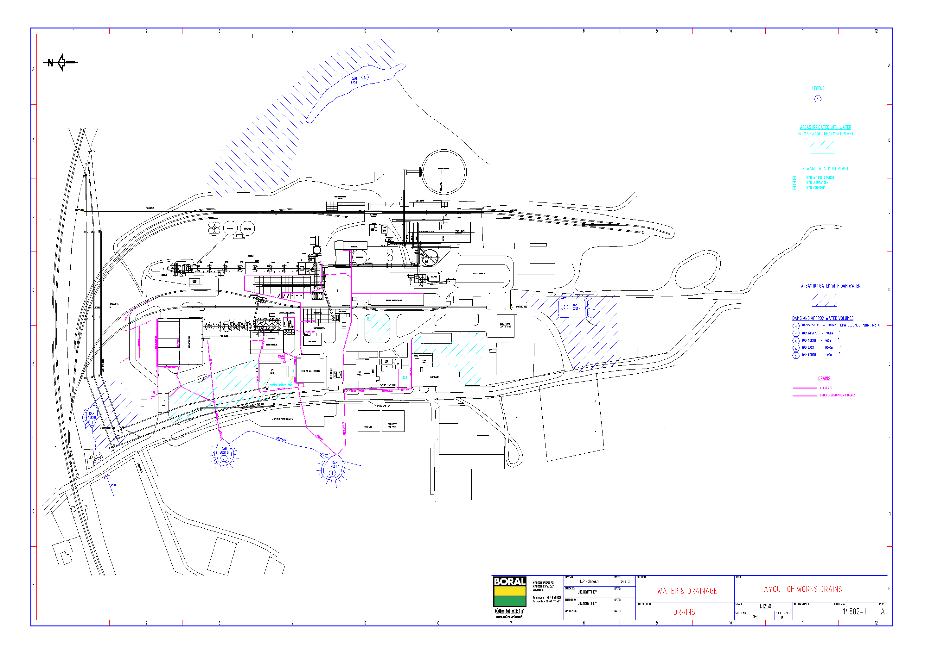
Map 1 - Site location

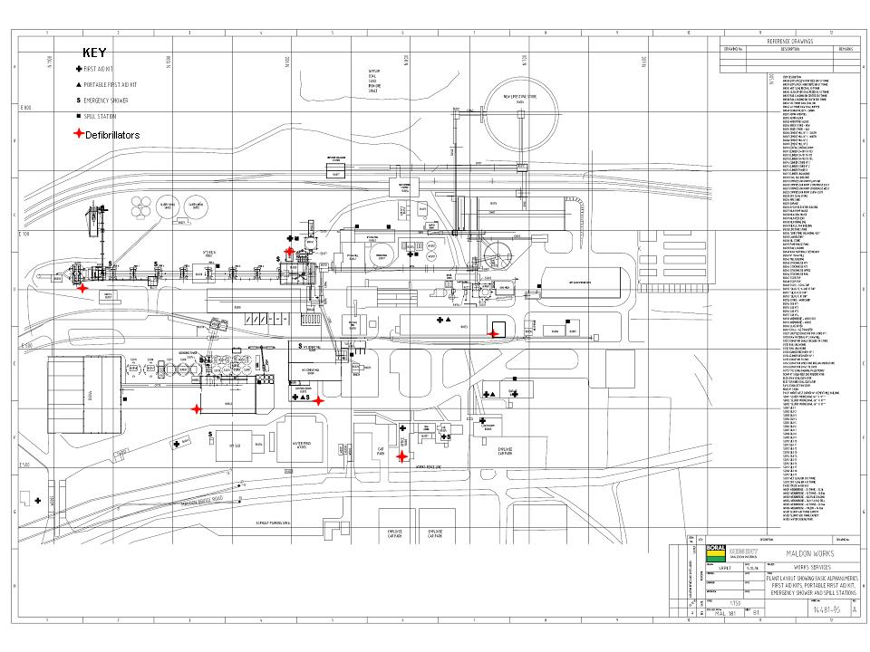
Map 2: Location of emergency equipment

    - Safety Equipment
The site utilises spill kits provided by specialised suppliers (as pictured below). An environmental spill kit register is located at http://dcmald01/sites/wizbizmaldon/HealthandSafety/EmergencyPreparednessResponse/MaldonEmergencyPreparednessResponse/Shared%20Documents/Environmental%20Spill%20Kit%20Service%20Report%20%20%20Maldon.pdf and contains current information regarding current stock and refill levels.
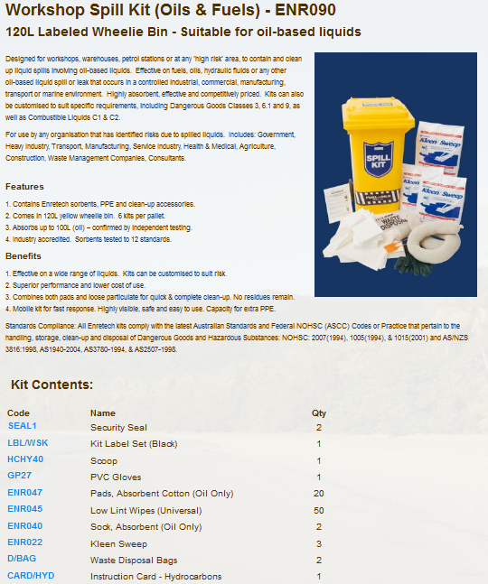

The following table is used to assist in determining the appropriate spill kit to use for various Hazardous / non-hazardous substances. Spill kits are to be used as per the manufacturer’s instruction.
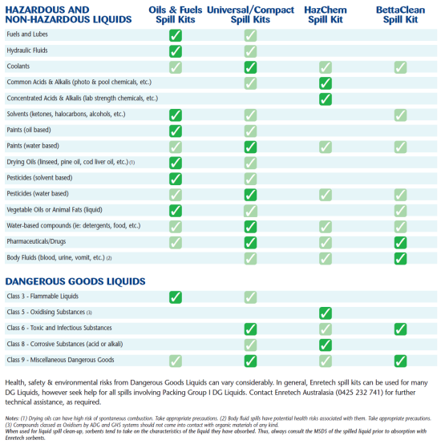

Spills are contained and remediated using the manufacturers recommended products as outlined below.
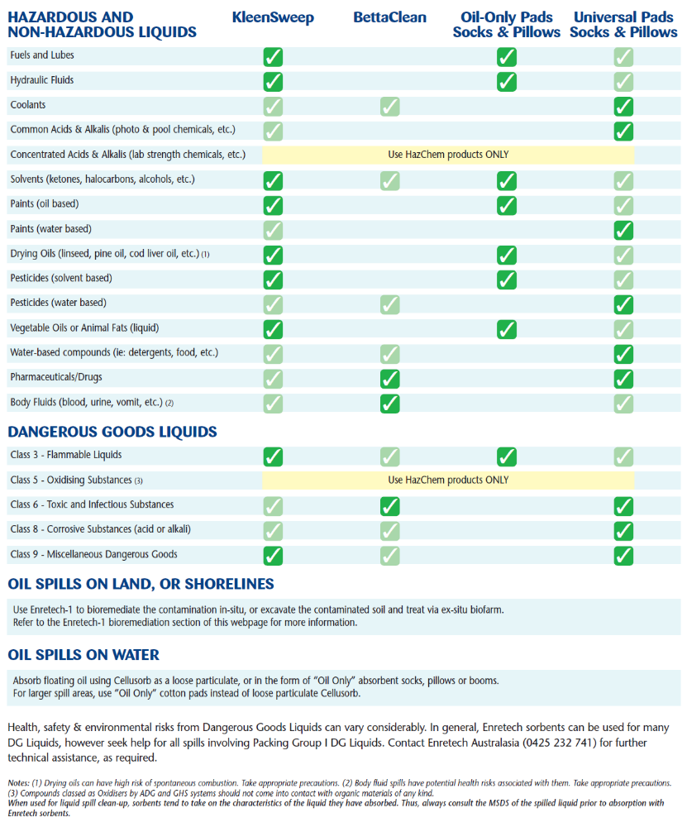

Fire protection systems are compatible with the hazardous substances and dangerous goods on site. The types of Fire extinguish used on site are appropriate for their application.

- Early Notifications
  - Immediate Notification of Government Authorities
Any pollution incident that causes or threatens “material harm” to the environment or people must be notified to government authorities immediately upon becoming aware of the incident. When new information comes to hand following the initial notification, this information must also be communicated immediately. For the definition of “material harm” caused by a pollution incident refer to Section 1.2.
“Immediately” means “without unreasonable delay”. Remember, safety first.
Only nominated Boral personnel are authorised to make notifications to the Authorities:

Frank Murnane | Plant Manager, Maldon | 02 4640 0203 | 0401 894 066
Ed Richardson | OHS Advisor, Maldon | 02 4640 0207 | 0401 894 518
Belinda Prideaux | Environment Manager, Boral Cement | 02 4820 3048 | 0401 893 359

All notifications are to be in line with standard operation procedure CMT-ENV-001 – Maldon Pollution Incident Notification, located in WizBiz Reference Library (Site procedures - Maldon).
The contact list of Compulsory Authorities is presented in Appendix A. Other Authorities may need to be notified as appropriate; however the Compulsory Authorities must be notified in ALL cases requiring environmental notification. All immediate notifications and updates are to be recorded in the Pollution Incident Immediate Notification Log (CMT-ENV-001 – Maldon Pollution Incident Notification SOP).
In borderline situations, where the exceedance of the trigger level of “material harm” of a pollution incident may not be clear, a quick assessment including consultation with Boral environmental personnel should be undertaken to help the decision whether to notify or not.
Boral’s Senior Corporate Management must be informed promptly of the fact of immediate notification to the Authorities. This includes environmental personnel listed above, Ross Harper, Girish Yadwad, Belinda Prideaux and Scott Carter.

  - Notification of Neighbours
In case of pollution incidents that may potentially pose threat to the health and safety of the neighbours (e.g. toxic fumes, bushfire, fuel spill into recreational stream, release of a thick dust cloud, etc.), the neighbours must also be urgently notified.
The early warning of the neighbourhood will be undertaken by telephone by Chief Warden or delegate. The current contact list for neighbours is attached in Appendix B.
The initial notification should be brief and contain only a description of the environmental threat together with instructions what to do. For example:
- Due to a dust bag house failure, we are experiencing elevated dust emissions from the site. Please keep your doors and windows closed until further notice.
- An accidental trade effluent discharge occurred from the site to a local creek. Please refrain from recreational use of the area until testing confirms that the water is safe.
- Due to a diesel spillage onto a street from the site, a cleanup operation is being organised. Please be watchful for road closures in relation to this operation.
A follow up information on the resolution of emergency situation would be timely conducted also on the phone. If required, further information would be disseminated by means of leaflets in a letterbox drop.

- Pollution Incident Emergency Response
In the event of a pollution incident the risk of harm to human health and the environment will be minimised by engaging an appropriate pollution response as outlined below
- Stop the source: If it‘s safe to do so, stop the process causing the spill/leak or other environmental incident.
- Isolate the area: The first person to notice the spill or leak should remove themselves from the immediate area and take measures such as barricading the area to reduce the risk of exposure to others. This must occur without exposure to danger.
- Commence early notification: The Manager or Supervisor must be notified immediately of the environmental incident. They in turn must immediately inform one of the persons nominated for notification of Authorities (see Appendix A). If the environmental incident is significant, the nominated person implements early notification procedures to the relevant Authorities including emergency services. Alerting the potentially affected neighbours may also be required (see Appendix B), with regular updates provided as needed.
- Provide a 1st aid response (if required): First aid kits including instruction on use are available at the locations indicated in Site Emergency Response Plan. Emergency shower and eye wash bays are suitably located, easily accessible and in good working order. Appropriate PPE is worn by all staff during periods of potential exposure as outlined in relevant MSDS.
- Identify the release to the greatest extent possible: Do so without being at risk. This includes identifying:
  - the type of material released;
    - Class 1 Explosives
    - Class 2 Gases - compressed, liquefied or dissolved under pressure.
    - Class 3 Flammable Liquids
    - Class 4 Flammable Solids, Substances liable to spontaneous combustion and Substances which in contact with water emit flammable gases
    - Class 5 Oxidizing Agents and Organic Peroxides
    - Class 6 Toxic and Infectious Substances
    - Class 7 Radioactive Substances
    - Class 8 Corrosive Substances
    - Class 9 Miscellaneous Dangerous Goods
  - The label and Material Safety Data Sheet for the product should give information on safe cleanup.
  - The size of the release and whether the release has stopped;
  - Whether two potentially incompatible chemicals are involved; and
  - Any unusual features such as foaming, odour, smoke, etc.
- Determine the level of emergency: review chemical risk assessments, seek internal advice from area specialists, review MSDS’s and seek professional advice from the fire brigade and/or hazardous material specialists.
- Determine if evacuation is required and consider the impact that wind, rain, local geographical features such as hills and stormwater drainage systems may have in exposing persons at emergency assembly points. If in doubt commence evacuation to “cold zones” Following a Pollution / Hazardous Material Incident the Emergency Site is to be divided into Hot, Warm and Cold Zones - for management purposes. The Chief Warden is responsible for the management of the COLD ZONE; all personnel are to be evacuated from the hot/warm zone.
Hot Zone this is the area of likely contamination. Only personnel wearing the appropriate level of protective clothing and equipment are to enter this zone. The area of the Hot Zone is defined, controlled and co-ordinated by the Hazmat Controller (FIRE BRIGADE).
Warm Zone this is the area immediately surrounding the Hot Zone where decontamination takes place and personnel and equipment are prepared for deployment. Only personnel wearing the appropriate level of protective clothing and equipment are to enter this zone. The area of the Warm Zone is defined, controlled and co-ordinated by the Hazmat Controller (FIRE BRIGADE).
Cold Zone this is the area immediately surrounding the warm zone. It is the support area where access is limited to support agencies personnel and equipment. This zone contains the Site Control, triage and treatment facilities and other marshalling and assembly areas. The Cold Zone is free of contamination and personnel protective clothing is not required. The area of the cold zone is defined by the site controller in consultation with the Hazmat Controller and managed by the CHIEF WARDEN.
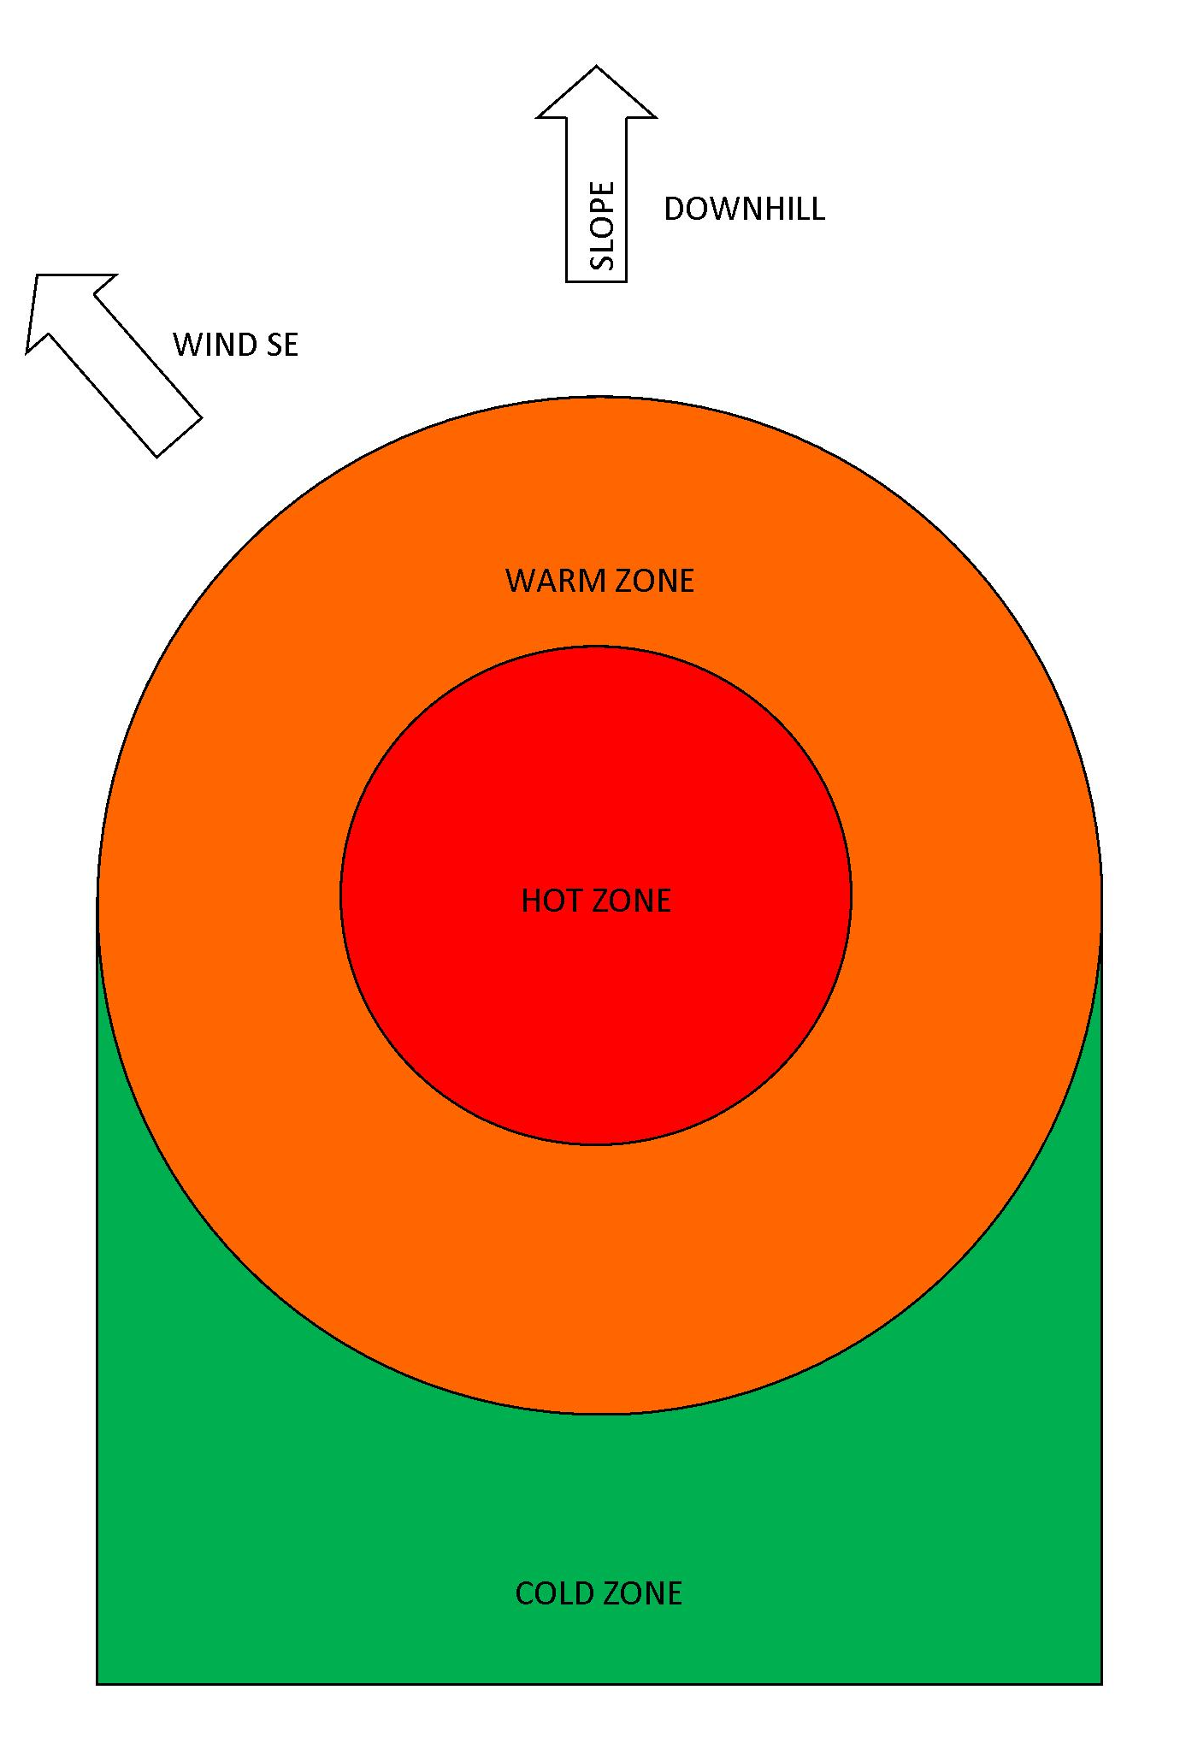
- Stop further release (if not done prior): prevent further release by isolating the source of the release. (Trained personnel only with suitable PPE)
- Stop the release from spreading (if safe to do so):
  - Prevent off-site release of contaminated stormwater: Protect stormwater grates with booms, covers or drain socks.
  - Liquid spills: Deploy spill kits to prevent further contamination dispersal, using appropriate absorbent/containment materials such as loose absorbent, socks or pads (land) and booms (water). See also CEM-ENV-014 Spill Prevention and Control.
  - Powdered solid spills: Lower down the silo rolling doors to minimise dust, cover stormwater grates to prevent ingress of solids.
  - Releases of pollutants into the air: Shut down ventilation systems to keep gases, vapours and dust from spreading.
- Large spills: Summon specialist spill emergency response contractors (e.g. Transpacific Industrial Solutions, 1800 SPILLS).
- Fire: If possible, endeavour to prevent fire-fighting water from entering the stormwater drains as it typically carries contamination. If possible, divert fire from areas containing materials that may generate toxic fumes when burned (e.g. stores of chemicals, cleaning aids, motor oil, etc.).
- Dispose of contaminated spill clean materials and wastes using a licensed contractor.
- If required, remediate the site.

ALERT CCR – Ext 299

cHIEF WARDEN

Early NOTIFICATION |  | EMERGENCY RESPONSE
REMOVE ALL PERSONS FROM HARM
ISOLATE THE AREA

Immediately CONTACT  BORAL CEMENT management |  | PROVIDE 1ST AID  ENSURE SAFETY OF OTHERS
FRAnk murnane  OR  ED RICHARDSON  BELINDA PRIDEAUX |  | PROVIDE 1ST AID  ENSURE SAFETY OF OTHERS
FRAnk murnane  OR  ED RICHARDSON  BELINDA PRIDEAUX |  | IDENTIFY THE SPILL  - The type of material released;  - The size of the release and whether it has stopped;  - Whether potentially incompatible chemicals are involved  - Any unusual features such as foaming, odour, smoke, etc.  - Discuss with hazardous material specialist / Fire Brigade  - Review MSDS
IMMEDIATE NOTIFICATION OF AUTHORITIES
- EPA – Environment Line
- Fire& RESCUE NSW
- Wollondily Council
- WorkCover
- Public Health Unit (Sydney South West)
- Other as appropriate

Complete Notification log  CMT-ENV-001 |  | CONTAIN THE SPILL / PREVENT FURTHER RELEASE  (If safe and if trained to do so)
inform senior boral management  rOSS hARPER  girish yadwad  Belinda prideaux  scott carter |  | DETERMINE “COLD ZONE”  RESTRICT ENTRY TO WARM & HOT ZONES
Chief Warden to determine  if alerting the neighbours is required |  | Chief Warden to determine  IF EVACUATION is required
Reception to alert the neigbours  by phone  contact list - refer Appendix B |  | summon emergency cleanup contractors  Transpacific, 1800 SPILLS
 |  | REMEDIATE

- Training and Testing
The Emergency Planning Committee will be responsible for training and testing the content of the emergency response (including Pollution Incident Management Plan) annually. Pollution incident testing will be undertaken within 1 month of any pollution incident occurring in the course of an activity to which the licence relates so as to assess, in the light of that incident, whether the information included in the plan is accurate and up to date and the plan is still capable of being implemented in a workable and effective manner.
Staff training is recorded in the Training Matrix.
Emergency Response Plan is reviewed annually through a consultation process. Testing schedule and drill log are maintained in the Emergency Response folder located in the main office, CCR, mechanical workshop and electrical workshop.

- Revision History
Version | Change Date | Summary of Change | Prepared by | Approved By
Rev.0 | 1 September 2012 | New document | Alex Wnorowski | Debbie Cook
Rev.1 | 1 September 2013 | Incorporating company structure changes- Formatting | Alex Wnorowski | Debbie Cook
Rev.2 | 1 September 2014 | Annual review | Alex Wnorowski | Alex Wnorowski
Rev.3 | 1 September 2015 | Annual review | Alex Wnorowski | Alex Wnorowski
Rev. 4 | 12 September 2016 | Annual review | Edward Richardson | Edward Richardson
Rev. 5 | 14 March 2017 | Annual review | Edward Richardson | Edward Richardson
Rev. 5 | 17 August 2018 | Annual review | Edward Richardson | Edward Richardson
Rev. 6 | 17 August 2018 | Annual review | Edward Richardson | Edward Richardson
Rev. 7 | 10 May 2019 | Annual review – updated contact details | Edward Richardson | Edward Richardson
APPENDIX A: Pollution Incident Authority Notification Contacts
Government Authority - Compulsory Notifications | Emergency notification phone number
EPA – Environment Line | 13 15 55
Fire & Rescue NSW | 1300 729 579
Wollondilly Shire Council | 02 4677 1100
Public Health Unit (Sydney South West) – Camperdown Office | BH: 02 9515 9420  AH: 02 9515 6111  Ask for Public Health Officer on call
SafeWork NSW | 13 10 50  Boral Cement ABN: 62 008 528 523
Government Authority - ring if relevant | Emergency notification phone number
Roads and Maritime Services (road spills) | 132 701
NSW Office of Water | 02 8838 7885
Bush Fire Control Officer | 1800 049 933
Poisons Information Centre | 131 126
Endeavour Energy (power line emergencies) | 131 003

APPENDIX B: Bulk Storage

Store | Chemical Class | Chemical | Storage Type | Bund Capacity | Storage Capacity
Yard | C1 | Diesel | Above Ground Tanks | 9000 litres | 9000 litres
Slag Dryer 1 | C1 | Diesel | Above Ground Tanks | 5000 litres | 5000 litres
Slag Dryer 2 | C1 | Diesel | Above Ground Tanks | 4500 litres | 4500 litres
Kiln 1 | C1 | Diesel | Above Ground Tanks | 17000 litres | 17000 litres
Kiln 2 | C1 | Diesel | Above Ground Tanks | 17000 litres | 17000 litres
Gas Farm | C2.1 | LPG | Above Ground Tanks | n/a | 45000 litres  6 x 7500l

See www.environment.nsw.gov.au

